**Date: 02-03-2020**

**Author-MD Fakrul Islam**

[**fakrul.islam@tsi.com.bd**](mailto:fakrul.islam@tsi.com.bd)

**Edge Computing for Reference Implementation**

**(Intel® DevCloud for the Edge)**

**\*\*\*\*\*Note**

**The below inferencing computation requires an active account in Intel® DevCloud for the Edge. All the examples were shown from the account of, “u37452-fakrul.islam@tsi.com.bd”**

#Step 1:

Create a directory “EdgeComputation” under, **u37452@s099-n003:~/Model_32$**

#Step 2:

Copy all class levels and image input files into the directory, “EdgeComputation”

1. **u37452@s099-n003:~/Model_32$ cp MHL.JPG EdgeComputation/**
2. **u37452@s099-n003:~/Model_32$ cp PHL.JPG EdgeComputation/**
3. **u37452@s099-n003:~/Model_32$ cp TLB.JPG EdgeComputation/**
4. **u37452@s099-n003:~/Model_32$ cp maize.labels EdgeComputation/**
5. **u37452@s099-n003:~/Model_32$ cp tomato.labels EdgeComputation/**
6. **u37452@s099-n003:~/Model_32$ cp potato.labels EdgeComputation/**

#Step 3:

Download “TSIAILAB_Edge_Node_Compute.ipynb” from the git:

<https://github.com/tsiAILAB/Plant-Pathology>

Upload TSIAILAB_Edge_Node_Compute.ipynb at:

**/home/u37452 in the intel dev cloud edge**

**\* further steps continued on next page**

#Step 4:

Run each cell of the notebook to finish the optimization.

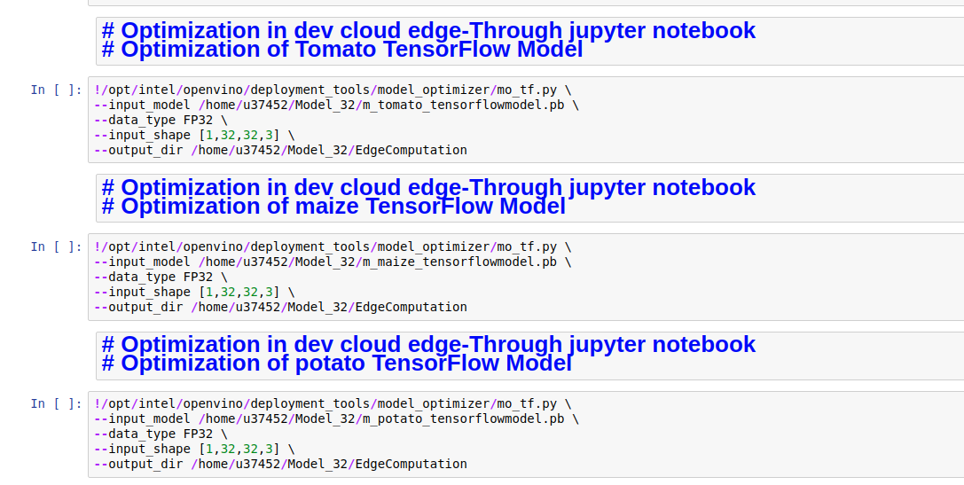

#Step 5:

Create 3 JOBs (tomato_job.sh, potato_job.sh and maize_job.sh) to put in the queue to provide in the EDGE NODE. Please execute the cell one by one.

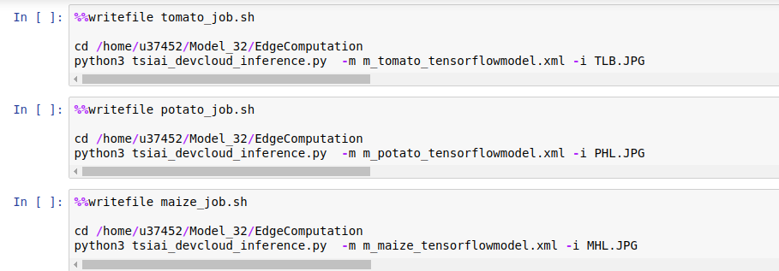

#Step 6: Reference Implementation, Case 1:

# Reference implementation -edge compute

# https://www.ieiworld.com/en/product/model.php?II=525

# TANK-870-Q170

Run following cells to execute 3 jobs in 3 nodes of the Intel Core i5 CPU (Tank 870) platform:

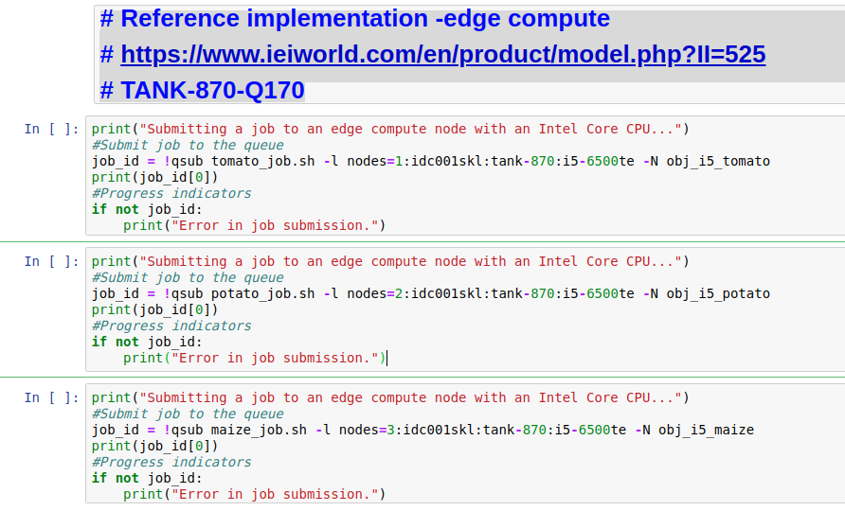

You will find inferencing result as:



For Example, if you browse to

<https://jupyter.edge.devcloud.intel.com/user/u37452/edit/obj_i5_maize.o3920>

You will get the result as

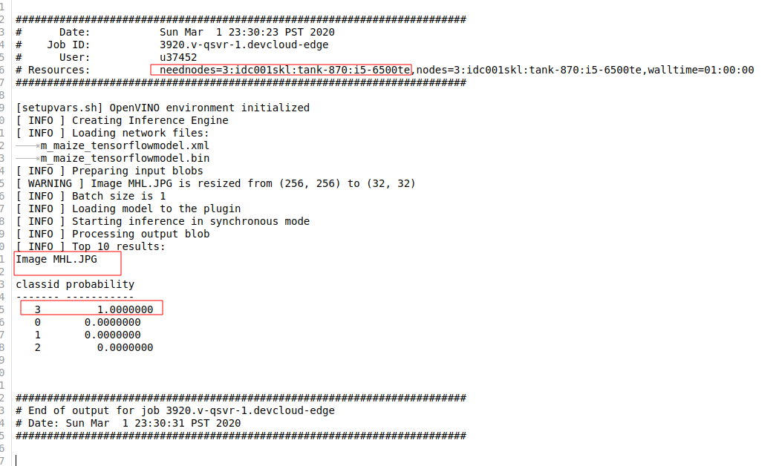

**\* Maize Healthy Leaf is correctly identified at the edge node.**

#Step 7 : Reference implementation, Case 2:

# Reference implementation -edge compute

# https://www.aaeon.com/en/p/iot-gateway-maker-boards-up-core-plus

# Atom™ x7-E3950 Processor SoC

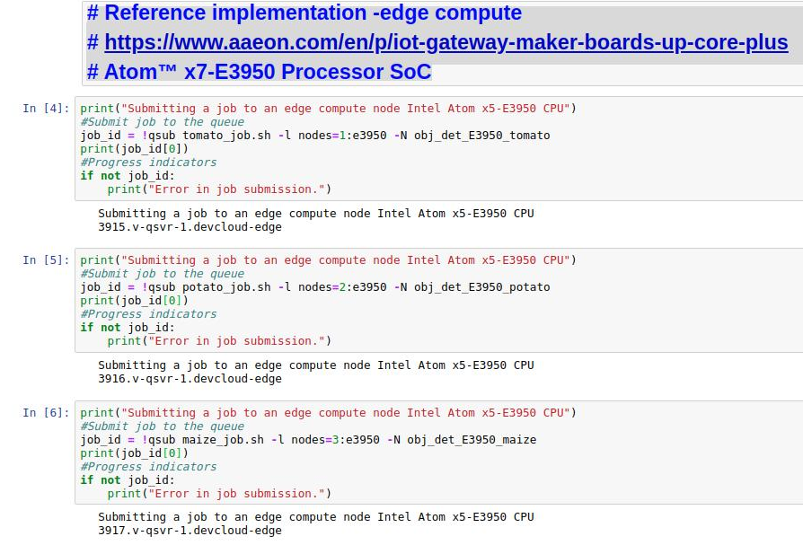

Run below cells to execute 3 jobs in 3 nodes of the Atom-E3950 platform.

You will get the inference result as:



For example, if you browse to:

<https://jupyter.edge.devcloud.intel.com/user/u37452/edit/obj_det_E3950_tomato.o3921>

You will get the result as:

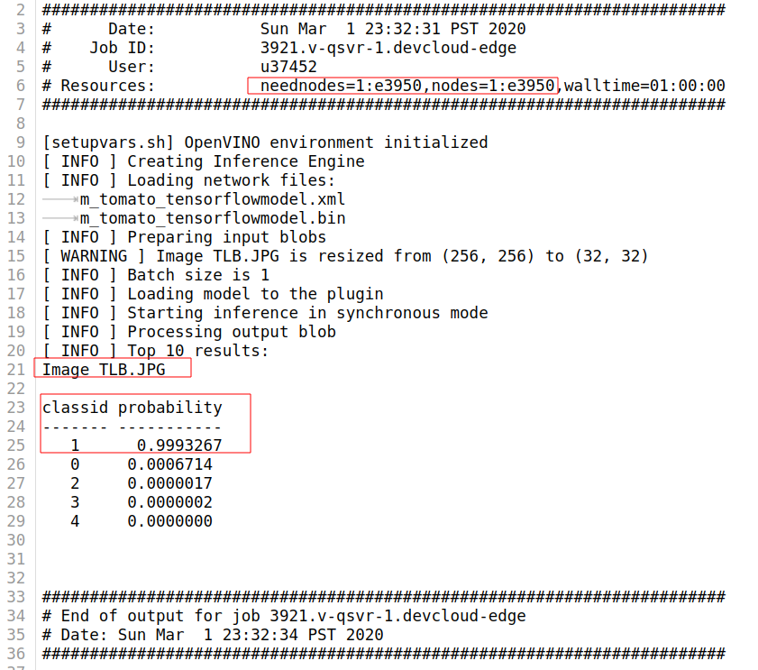

**\* Tomato Late Blight Leaf is correctly identified at the edge node.**